[](https://www.housing21.org.uk/)

**Pests Policy**

If you need any information in a different format, for example large print, Braille, audio file or another language, please email [Communications@housing21.org.uk](mailto:Communications@housing21.org.uk)

|  |  |
| --- | --- |
| **Version number** | 1.0 |
| **Issue date** | November 2024 |
| **Review date** | November 2027 |
| **Board approval required?** | No |
| **If yes, date approved by Board** | N/A |
| **Author’s name and job title** | Angela Hill Project and Change Manager |
| **Policy owner and job title** | Kris Peach MD Extra Care |
| **Policy Steering Group approval date** | November 2024 |

# **Summary**

This policy sets out our approach to preventing and resolving pest infestations by:

* Outlining how Housing 21 and residents can prevent and tackle pest infestations.
* Outlining the responsibilities of Housing 21 and residents for treating pests.

# **Equality, Diversity and Inclusion**

Housing 21 aspires to embed diversity and inclusion within all our organisational activities to enable these principles to become part of our everyday processes. in accordance with the Equality Act 2010 we will consider reasonable adjustments in our approach where an infestation may be attributed to the resident having a particular health condition.

1. **Definition of Pests and Infestations**

**1.1 Pest Infestations:** A pest is widely considered to be any organism (typically vermin or insects) that causes harm, nuisance, or damage. An infestation is the presence of pests in unusually large numbers, see the [British Association of Pest Control](https://bpca.org.uk/pest-advice/a-z-of-pests).

Infestations that are prejudicial to health, may meet the [Environmental Protection Act 1990](https://www.legislation.gov.uk/ukpga/1990/43/part/III/crossheading/statutory-nuisances-england-and-wales) definition of *statutory nuisance* or may be considered a *hazard* under the [Housing Health and Rating System](https://assets.publishing.service.gov.uk/media/5a799834ed915d0422069a0a/150940.pdf) if it leaves the property unfit for habitation. In both cases there are obligations on the Local Authority and Housing 21 as the landlord to take action to resolve the issue.

**1.2 Serious Pest Infestations:** Are those that are a risk to public health or spread disease e.g.

* Rats or mice-where present in unusually large numbers.
* Bedbugs which can spread to the whole building and can be difficult to eradicate.
* Cockroaches that may spread disease.

1. **Pest Prevention**

Housing 21 will take reasonable steps to prevent pests in our communal areas as well as offer advice on prevention of pests to residents. Residents are required to notify their manager if they suspect an infestation, particularly for serious pests such as bed bugs.

Any behaviour by residents which may attract pests to their property, such as feeding pigeons, poor property hygiene or leaving open food sources will be strongly discouraged and, where persistent, may be addressed as a tenancy breach.

1. **Responsibilities for Eradication of Pests**

**3.1 Residents:** are responsible for the prevention, treatment (and associated costs) of most common pest infestations within their own private property. Where possible, Housing 21 will offer advice or assistance in sourcing services or products for the eradication of pests. However, residents will be responsible for their decision to purchase and all associated costs.

**3.2 Housing 21**: are responsible for the treatment of pest infestations in the internal/external communal areas. Responsibility may extend to residents’ homes if evident that an infestation has spread from a communal area or if the cause is found to be a fault in the fabric of the building. Pests will be treated within an appropriate timescale that considers the impact and risk to people, environment, and property. Housing 21 will seek professional advice where appropriate and will make use of free Local Authority services where applicable.

Housing 21 may also intervene where there is a serious infestation (such as bed bugs) in a resident’s property that risks spreading to communal areas, or other residents’ properties. Where access is denied, we may need to take legal action to gain access to treat the issue.

Where an infestation is caused by a resident’s actions, or inactions, such as poor property hygiene or leaving open food sources, a recharge may be made to the resident for the costs of pest treatment and any remedial works.

Where a resident is required to move out of their home whilst pest treatment takes place this will be managed in accordance with the Decant Policy.

**3.3** Housing 21 cannot take action to remove any animals protected by law and additionally, will not normally investigate, or take any action to:

* Prevent nesting birds in communal areas, or birds such as pigeons landing on balconies.
* Prevent wild animals entering communal gardens (such as foxes or rabbits).

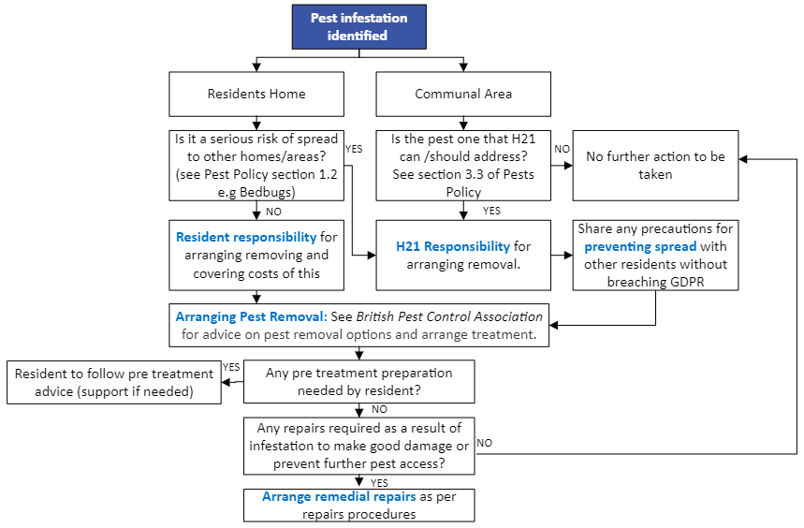

**Pests Procedure:**

1. **Arranging pest removal.**

The urgency of pest removal will depend on the risk to health, property damage, and potential spread of the infestation using guidance published by [British Pest Control Association](https://bpca.org.uk/). One or more of the following options should be used:

1. Purchasing or using a household product- such as ant powder.
2. Reporting to the Local Authority (using the appropriate method for that authority) providing the pest is one that they are responsible for treating-see [Pest Control.gov.uk.](https://goheretoenter-my.sharepoint.com/personal/angela_hill_housing21_org_uk/Documents/COMPLAINTS/Find%20out%20about%20pest%20control%20-%20GOV.UK%20(www.gov.uk))
3. Using a specialist or commercial pest service- see [British Pest Control Association](https://bpca.org.uk/).

Any treatment guidance and/or preparation- such as removal or disposal of items or furnishings should be followed.

1. **Preventing spread of the pest infestation.**
2. The employee/resident(s) should follow any treatment guidance and preparation advice and take any necessary precautions to prevent further spread of the pests.
3. Where infestations have spread to other properties/areas, other residents should be notified (without breaching GDPR by sharing resident name or flat number) of any precautions to take see [British Association of Pest Control](https://bpca.org.uk/pest-advice/a-z-of-pests) for guidance.
4. **Arranging remedial repairs to prevent ingress or rectify damage.**
5. Where repairs are required to prevent pest ingress or rectify damage caused by the pest, these should be arranged in accordance with Housing 21 repairs policy and procedures.

A record of pests should be made as a file note on the resident file or for communal areas should be made in the scheme diary.